[The News International](https://www.thenews.com.pk/)

**Islamabad: Passenger off-loaded from flight after praying for plane to crash**

The News International

20 hrs ago

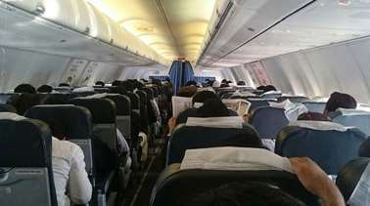©

Provided by The News International

File photoISLAMABAD: A man left passengers and crew on board a Dubai- bound flight in shock and horror with his unusual prayer.

According to Geo News, pilots called the Airport Security Force (ASF) personnel after the passenger identified as Khalil started praying for the aircraft to crash as soon as he sat on his seat.

The ASF officials offloaded Khalil who was due to fly to Australia via Dubai.

It was not immediately clear what caused the man to wish for destruction.